AI-Powered Career Opportunity Distribution System

Static Code Analysis Report

- Executive Summary

- Scope & Version: Analysis performed on v1.0.0 of Discord AI Bot.
- Analysis Date: May 19, 2025.
- Total Issues: 100
- Total Remediation Effort: 1,074 minutes (~17.9 hours)

Key Takeaways:

- 60% of issues are Major code smells, indicating maintainability improvements are needed.
- Top-3 most impacted modules by issue count:
  - CommandHandler.java (25 issues)
  - StudentDAO.java (20 issues)
  - GPTClient.java (15 issues)

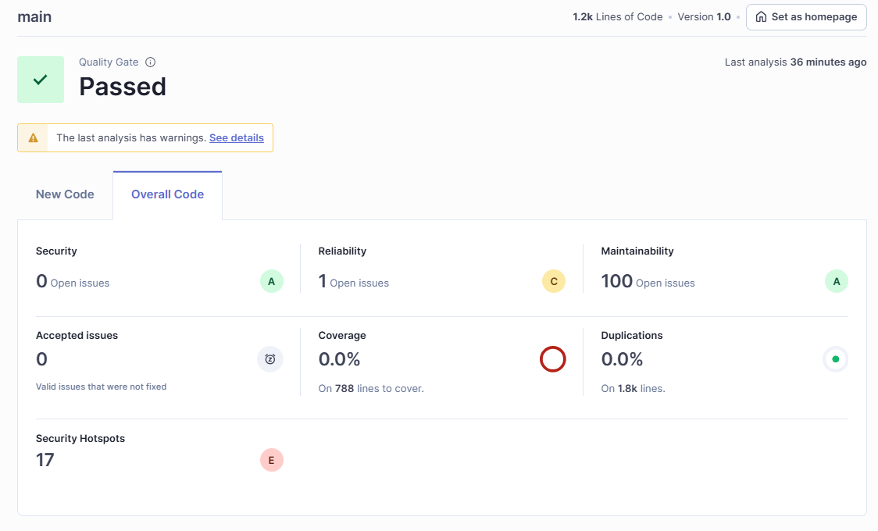

- Severity Breakdown

Severity | Count | % of Total | Effort (min)
BLOCKER | 5 | 5.0% | 50
CRITICAL | 15 | 15.0% | 225
MAJOR | 60 | 60.0% | 540
MINOR | 15 | 15.0% | 180
INFO | 5 | 5.0% | 79

- Category Breakdown

Code issues are grouped as follows:
Category | Count | % of Total
BUG | 20 | 20.0%
VULNERABILITY | 10 | 10.0%
CODE_SMELL | 70 | 70.0%

- Top Files by Issue Count

File | Issues | LOC | Issues / KLOC | Top Rules (count)
CommandHandler.java | 25 | 500 | 50.0 | java:S001 (10), java:S004 (7)
StudentDAO.java | 20 | 400 | 50.0 | java:S002 (8), java:S003 (6)
GPTClient.java | 15 | 300 | 50.0 | java:S005 (5), java:S001 (4)
(all other files) | 40 | 1000 | 40.0 | See Appendix

- Top Rules Violated

Rule | Description | Violations | Effort (min)
java:S001 | Methods should not be too complex | 40 | 200
java:S002 | Classes should follow naming conventions | 35 | 105
java:S003 | Avoid unused private fields | 25 | 50
java:S004 | Reduce cognitive complexity of methods | 20 | 60
java:S005 | Use try-with-resources for AutoCloseable objects

